

**CloverApp Mobile Point of Sales**

**By:**

**Rodger Arteta**

**Ryan Lanuzo**

**Final Document Submitted in Fulfilment of the**

**Requirements for the Course of CSPROJ2**

**Asia Pacific College**

**Date Created:**

**September 05, 2017**

**Submitted to:**

**Sebastian Manuel Sanchez**

**Contents**

**I.** **Introduction** 5

**II.** **Related Software** 6

**III.** **Technical Background** 9

**IV.** **Methodologies, Results and Discussion** 9

**V.** **Conclusions and Recommendations** 10

**VI.** **Appendices** 11

**Use Case** 11

**Functional Decomposition Diagram** 12

**State Transition Diagram** 13

**Entity Relationship Diagram** 14

**Sequence Diagram** 15

**Activity Diagram** 16

**Context Diagram** 17

**Data Flow Diagram** 18

**Vision and Scope Document** 19

**Revision History** 19

**1. Business Requirements** 19

**1.1. Background** 19

**1.2. Business Opportunity** 19

**1.3. Business Objectives and Success Criteria** 20

**1.4. Customer or Market Needs** 20

**1.5. Business Risks** 20

**2. Vision of the Solution** 21

**2.1. Vision Statement** 21

**2.2. Major Features** 21

**2.3. Assumptions and Dependencies** 21

**3. Scope and Limitations** 22

**3.1. Scope of Initial Release** 22

**3.2. Scope of Subsequent Releases** 22

**3.3. Limitations and Exclusions** 22

**4. Business Context** 23

**4.1. Stakeholder Profiles** 23

**4.2. Operating Environment** 25

**Statement of Work Document** 25

**Introduction/Background** 25

**Scope of Work** 25

**Period of Performance** 25

**Place of Performance** 26

**Work Requirements** 26

**Schedule/Milestones** 28

**Acceptance Criteria** 28

**Other Requirements** 28

**Software Requirements Specification** 30

**Revision History** 30

**1.** **Introduction** 30

**1.1** **Purpose** 30

**1.2 Document Conventions** 30

**1.3 Intended Audience and Reading Suggestions** 31

**1.4 Product Scope** 31

**2. Overall Description** 31

**2.1 Product Perspective** 31

**2.2 Product Functions** 31

**2.3 User Classes and Characteristics** 32

**2.4 Operating Environment** 32

**2.5 Design and Implementation Constraints** 32

**2.6 User Documentation** 32

**2.7 Assumptions And Dependencies** 32

**3. External Interface Requirements** 33

**3.1 User Interfaces** 33

**3.2 Hardware Interfaces** 33

**3.3 Software Interfaces** 33

**3.4 Communications Interfaces** 33

**4. System Features** 34

**4.1 Login** 34

**4.2 Inventory Management** 35

**4.3 Sales Report** 36

**4.4 Sales** 36

**5. Other Nonfunctional Requirements** 37

**5.1 Performance Requirements** 37

### **Introduction**

#### **Project Context**

Poseidon IT Solutions had seen that there are start-up businesses who are dealing with their business operations manually this includes point of sale, inventory management, employee management, and daily/monthly sales reports. Poseidon IT Solutions had thought of creating a generic mobile point of sale that would entice small business owners which leads to the development of CloverApp. Poseidon IT Solutions requires us to create a mobile point of sale that would eliminate the said manual processes.

#### **Project Description**

The CloverApp is a mobile point of sale that will be marketed through various small business owners that has a transaction module, inventory management, employee management, and report summary. The transaction module is responsible for the transactions that had been made, inventory management is responsible for managing products that the business has, employee management is responsible for controlling access of each employee, and reports summary is responsible for providing sales data daily/monthly/annually.

#### **Objectives**

To create a mobile point of sale that the client deems marketable.

#### **Scope and Limitations**

* The business owner shall be responsible in putting their personal information on their invoice
* The Application’s payment method is cash only

### **Related Software**

**STOREHUB**

**Description:**

A mobile point of sale that is designed for IPAD. Store hub uses an IPAD that serves as a cash register.

**Features:**

* Real-time Reporting – Real time insights
* Offline Protection – Functions offline in case of no WIFI connectivity
* Quick & simple setup – Easy imports
* Free & automatic updates – Latest software updates for free
* Identify and Move Dead Stock – Identifies which items are not selling well to free up cashflow
* Never Run out of your Bestselling items – Gives automatic low stock alerts on your best-selling items
* Manage your supplier relationships – Send/Print purchase orders directly to your suppliers from StoreHub
* View/Transfer Inventory across multiple stores – Shares stock information across multiple branches of your store
* Track buyer activity – Identify customer’s spending habits
* News and announcements – Notifies customers on store news via SMS Messaging
* Customizable receipts – Receipts that can be personalized and customized to the business’s requirements
* Discounts & Promos – Give offers and set promotions

**Square POS**

**Description:**

A mobile point of sale that has the tools needed to run a business and can support businesses that needs a point of sale. Square POS also works on both apple and android devices.

**Features:**

* Customized Counter
* Receipt Options
* Open tickets and split tender – enables to keeps tabs and let customer’s pay at their convenience. Tabs could be split by cards or take payments multiple ways
* Real Time Inventory Management – Change item details in real time and track stock quantities and get alerts via email when items are low
* Speed up the queue with simple modifiers – Item modifiers is an efficient way to get customer’s exact order
* Clear pricing, no surprises - Process Visa, Mastercard and American Express at 1.9% per tap, insert or swipe. Manually enter card information and pay 2.2% per transaction.
* Serious security – Square encrypts transactions at the point of purchase and tokenises data
* Deposits the next business day – Square deposits money directly into your bank account in one to two business days
* Employee management – Control’s employee access
* Multiple locations, one account
* Send Invoices
* Accept Credit and Debit Cards
* Get private customer feedback
* Integrate with accounting and other apps

**iVend**

**Description:**

iVend enables retailers to engage and transact with shoppers from anywhere on the store or remotely via an android or IOS device. Staff can create more sales without leaving the side of the consumer.

**Features:**

* Easy to install - Available from the apple store or google play
* Broad Functionality – depending on set up preference and circumstance iVend Enterprise or iVend Store Management consoles are connected to mobile devices.
* Globally Enabled – Supports 12 languages as default, can add other languages
* Online/Offline Mode – Works online with wifi connectivity and works offline in case of internet connection issues and synchronizes with iVend Enterprise when network connection is restored.
* Multiple Tender Types - Full support for processing special pricing, promotions, loyalty rewards, paper or digital coupon based discounts, foreign currencies, gift cards and charges to account.
* Powerful Business Reports - Perform the End of Day operations right from mobile devices with inbuilt dashboards reporting transactions by value, count, tender details, X-tape, etc.
* Strong Security and Remote Support - Easily review the number of transaction voids, line item voids, cancelled and suspended sales etc. for loss prevention to investigate.
* Faster Data Synchronization – In online mode transaction validation such as special pricing, promotions, and coupons are applied immediately. The device has its own copy of the master data and these values that are used for transactions.
* Accommodates a Wide Range of Hardware.

### **Technical Background**

The following are tools used in developing the project:

Android studio is the official IDE for android app development, based on IntelliJ IDEA.

### **Methodologies, Results and Discussion**

**Requirements Analysis**

Mobile point of sale is a mobile application intended for smartphones, tablet or dedicated wireless device that functions as the cash register. An internet connection is required to get real time updates however, a mobile point of sale also functions offline in cases of internet connection issues.

**Requirements Documentation**

This requirements document states the requirements for the mobile point of sale system. The product prototype provides:

* Transaction Processing
* Online Invoice
* Reports Summary

**Design of Software, Systems, Product, and/or Process**

The software is developed using Android Studio with blank framework. Each table in the database are generated with a create, read, update, and delete feature depending on the needs of the mobile application.

**Development and Testing, where applicable**

The Structure used in this project is based on the Software Development Life Cycle (SDLC), using Extreme Programming (XP) method, XP is an agile practices-based methodology. XP stresses customer satisfaction, which gives the customers what they need instead of what they could possibly want on some date far in the future. XP is a collaboration of managers, customers, and developers that emphasizes teamwork.

Wells, D. (n.d.). Extreme Programming: A Gentle Introduction. Retrieved August 23, 2017, from http://www.extremeprogramming.org/

**Features to be tested:**

* Inventory Management
* Transaction Processing
* Reorder Point
* Online Invoice

**Description of the Prototype, where applicable**

The prototype that the team developed can manage inventory, processes transactions, and produce reports summary.

### **Conclusions and Recommendations**

After testing the created prototype, the developer should consider other features to make a marketable mobile point of sale. Research on the requisites to create a system such as a point of sale is highly important to avoid legality issues.

### **Appendices**

### **Use Case**

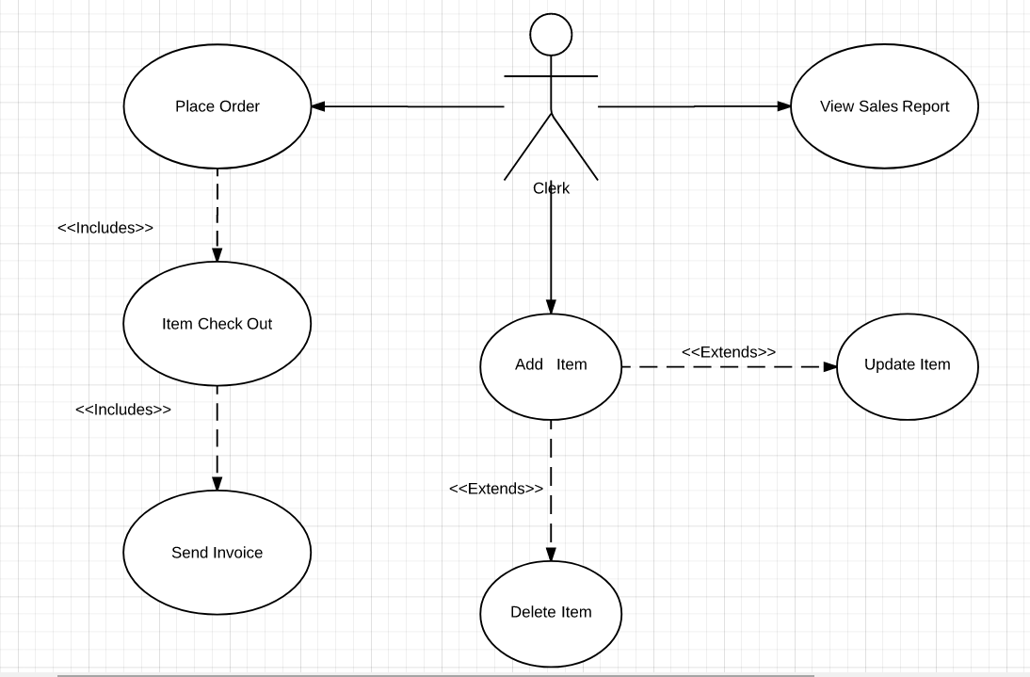

### **Functional Decomposition Diagram**

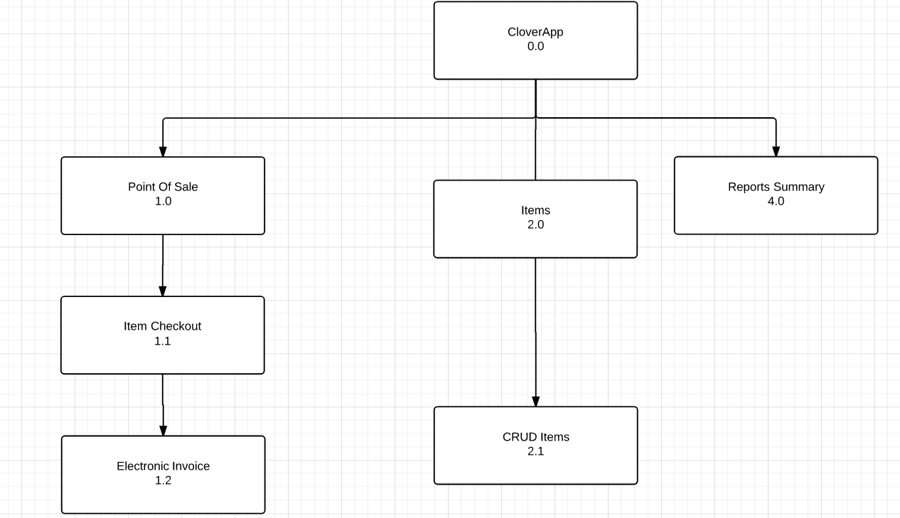

### **State Transition Diagram**

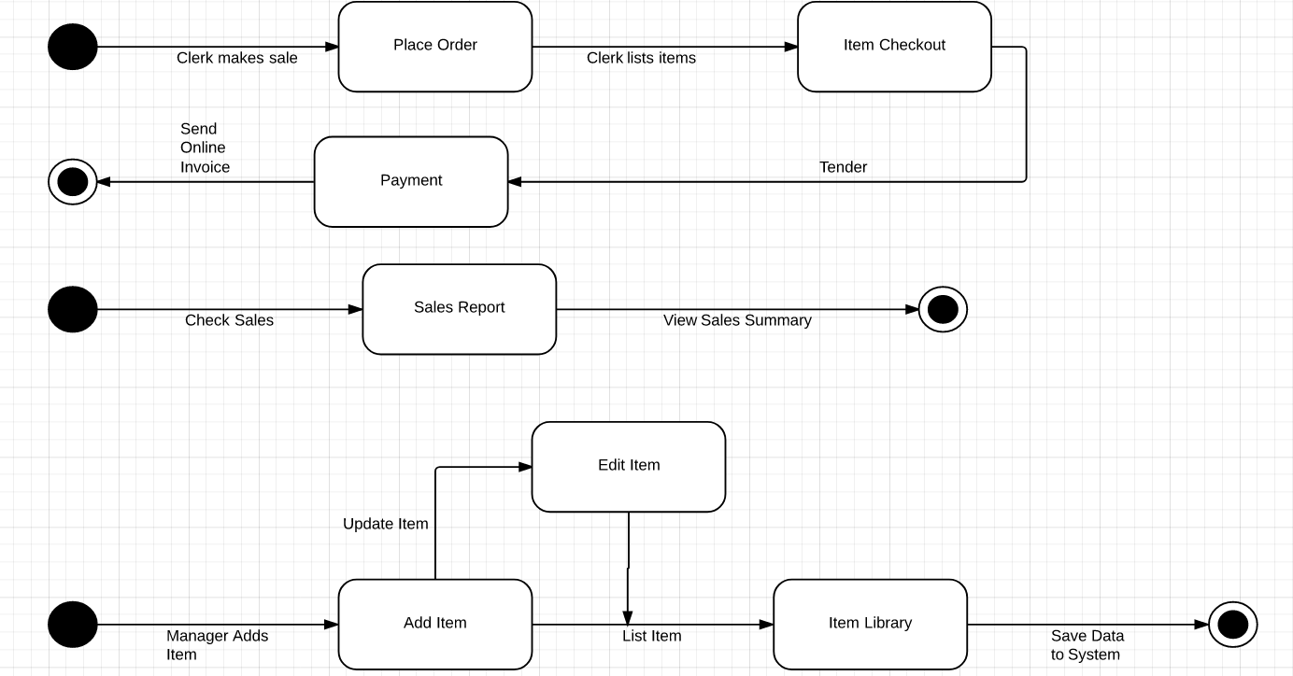

### **Entity Relationship Diagram**

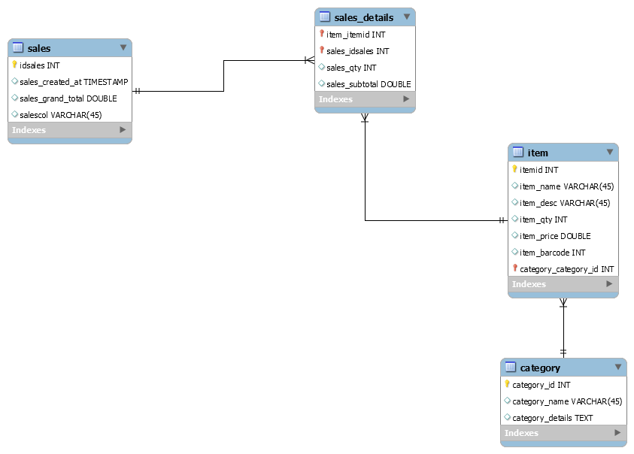

### **Sequence DiagramC:\Users\ryan\AppData\Local\Microsoft\Windows\INetCache\Content.Word\CloverApp Sequence Diagram - Page 1 (3).png**

### **Activity Diagram**

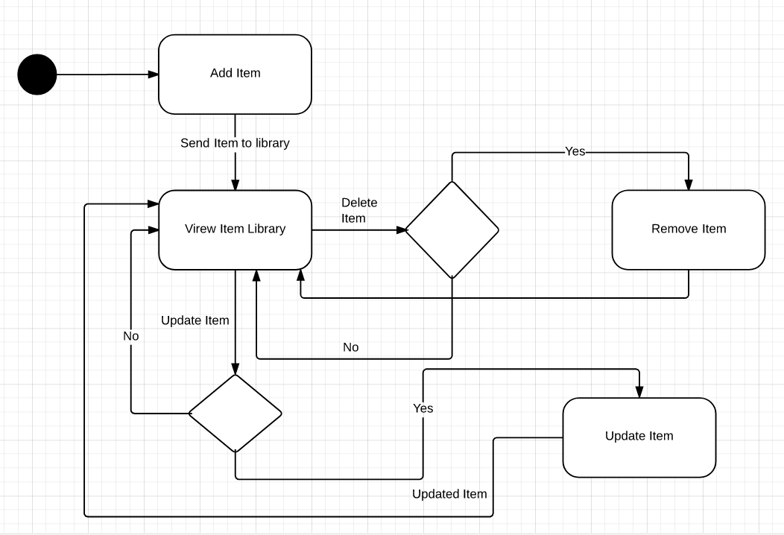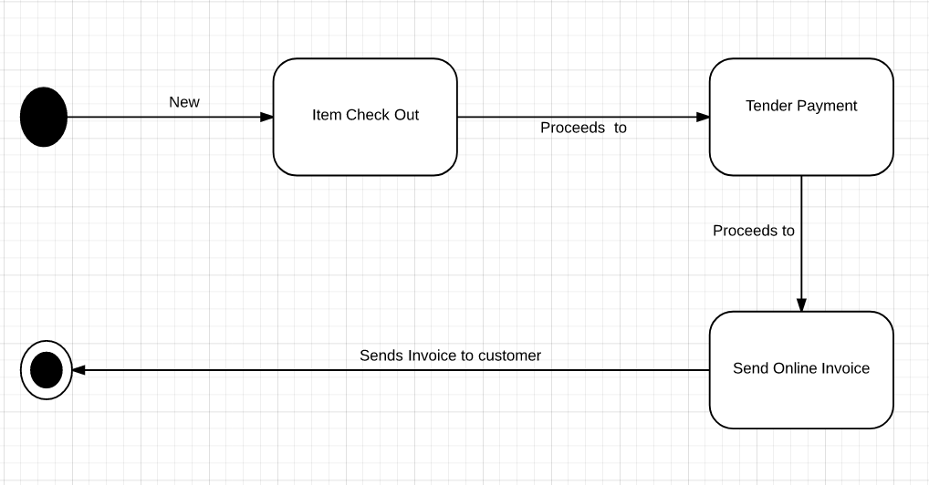

### **Context Diagram**

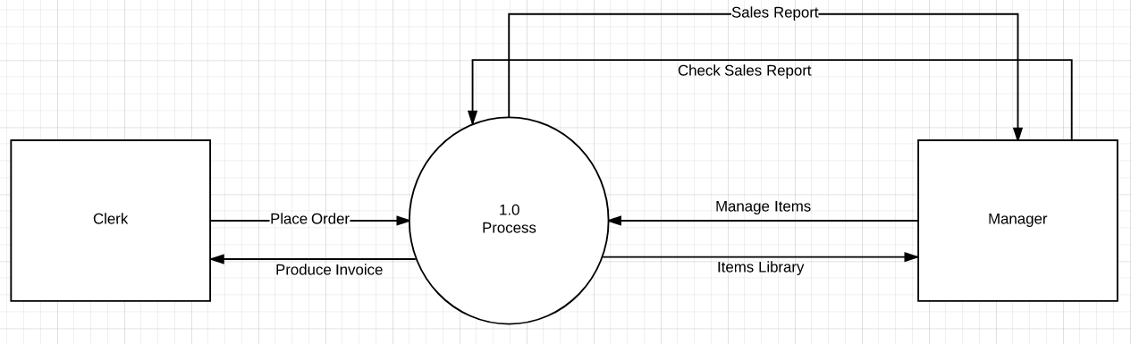

### **Data Flow Diagram**

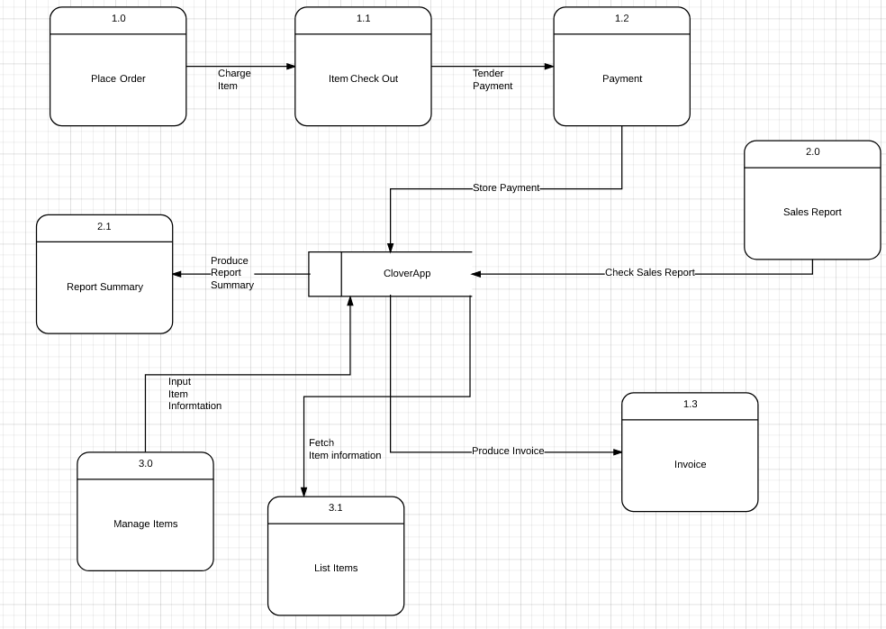

### **Vision and Scope Document**

# **Revision History**

|  |  |  |  |
| --- | --- | --- | --- |
| **Name** | **Date** | **Reason For Changes** | **Version** |
| Draft Vision and Scope Document | 6/21/2017 | Draft creation | 1.0 |
| Finalized Vision and Scope Document | 7/05/2017 | Proof Read | 2.0 |
| Updated Final Document | 7/09/2017 | Review | 3.0 |

# **1. Business Requirements**

## **1.1. Background**

Our client requires a Mobile Point of Sales System (PoS) which we will be deployed for public use that will be subscription based. The client has experience with a PoS through a desktop platform and wants to migrate to a mobile platform to flexibly view their sales and inventory.

The client is requiring us to build a system that fulfills their requirements and produce their desired output

## **1.2. Business Opportunity**

The team believes that the main competitor in the marketplace will be the existing mobile point of sales system. Existing mobile point of sales system are expensive and have too much functionalities that the client may deem unnecessary. The team believes that its competitive edge is the inexpensive price of the system with functions and features that the client needs.

## **1.3. Business Objectives and Success Criteria**

The mobile application must be able to do the basic functions of Creating, Updating, and Deleting items in the database. Provides a dashboard for all sales that will be made and also for tracking the store’s inventory. An employee management to keep the system information secure.

## **1.4. Customer or Market Needs**

Our client has requested for an application capable of handling different Point of Sales tasks on a mobile platform. It will be deployed in the Google Play Store it will be available for public use through subscription. Other potential clients are business owners (small startups that are related to the food and merchandising industry). The client has experienced using PoS through a desktop platform and wants to use a different approach by using a mobile device for a PoS System. The client must be able to access the system through a mobile device with the installed application.

## **1.5. Business Risks**

The risks for this system is that there are already existing systems available in the market and has more functionalities than our proposed solution and costs less or expensive. Typical Point of Sales System are accessed through a computer; however, there are already existing creations of a Point of Sales System in a mobile platform. The team believes that its proposed solution can be on par with existing solutions for a cheaper cost with functionalities that will cater the client’s requirements and expectations.

The team aims to make the solution as user-friendly as possible for ease of use. Possible implementation issues could be different mobile OS, the team will delve on android OS only and not apple IOS because of cost in development and the software will be used in development is Android Studio.

# **2. Vision of the Solution**

## **2.1. Vision Statement**

For the client and owners of small startups that are into the food and merchandise industry, the Mobile PoS is an internet-based application that will help in the tracking of inventories of products, sales, and sales forecast. The Mobile PoS will provide meaningful insights regarding the products, and monitor each product for inventory.

### **2.2. Major Features**

FE-1: Input item details from any mobile device with the installed application.

FE-2: View item stocks from any mobile device with the installed application.

FE-3: View statistical data such as frequency of items, top selling items, and sales.

### **2.3. Assumptions and Dependencies**

Assumptions:

* Development will be on android
* The business owner will be responsible for applying their own TIN number for online receipts
* The business owner will provide the mobile platform that has the minimum required specs
* The business owner will be responsible for adding important information about the company on the application to ensure nothing is disclosed.

Dependencies:

* There is still a need for a cashier to create a sale
* Email (for online invoice)

### **3. Scope and Limitations**

## **3.1. Scope of Initial Release**

With the limited time and resources, we will devote everything to create a user-friendly interface for ease of use and focus on the major features to comply with the standard requirements.

By the end of the initial release the system should have the following:

* Sales reporting and Analytics
* Inventory Management
* Produce sales invoice and item check-out.
* Employee Management

## **3.2. Scope of Subsequent Releases**

In addition to 3.1 any recommendation and suggestions by the client will be taken into consideration given that the limited time and resources are not yet exhausted.

## **3.3. Limitations and Exclusions**

The limitation of the project is the commitment to deploy only on Android OS. the team only has one programmer to develop the app and uses android studio for mobile development.

# **4. Business Context**

## **4.1. Stakeholder Profiles**

|  |  |  |  |  |
| --- | --- | --- | --- | --- |
| **Stakeholder** | **Major Value** | **Attitudes** | **Major Interests** | **Constraints** |
| Client | Initialized the project | see product as marketable | To see the final product as fully operational | Budget constraints |
| Managers and Clerks | Ease of inventory checking, retailing sales | N/A | Convenience; simplicity of use | Access of the system |
| Customers | Ease of item check out, convenient invoice copy | See product as useful in terms of performance and convenience | Online copy of invoice; Faster Transactions |  |
| Project Manager | The management of the project | Allocates time and resources for each project milestones | Increase in knowledge Android Studio and developing a Point of Sales System |  |
| System Analyst | Written requirements of the project | Allocates time and resources to complete project milestones |  |  |

**4.2. Project Priorities**

|  |  |  |  |
| --- | --- | --- | --- |
| **Dimension** | **Driver**  **(state objective)** | **Constraint**  **(state limits)** | **Degree of Freedom**  **(state allowable range)** |
| Schedule | specification finished by date, product delivered by date |  |  |
| Features |  |  | 70-80% of high priority features must be included in release 1.0 |
| Quality |  |  | 90-95% of user acceptance tests must pass for release 1.0, 95-98% for release 1.1 |
| Cost |  |  | budget overrun up to 15% acceptable without executive review |

## **4.2. Operating Environment**

The Mobile PoS will be used in different businesses that produce sales. As a mobile application it should be accessible to phones and tablets that uses Android OS.

# **Statement of Work Document**

# **Introduction/Background**

Poseidon IT Solutions has an idea for an application that would make a Point of Sales system on a mobile platform, a versatile way of managing inventory, quickly view a store’s performance through sales reports, and produce a paperless way of creating an invoice through electronic receipts. The project aims to reduce costs of a company for expensive hardware such as barcode scanner, and invoice printers also the project aims to create a marketable mobile Point of Sales system.

# **Scope of Work**

The scope of work for CloverApp includes user authentication for tier 1 security, Sales Reports and Inventory Management to view the store’s performance through charts, and Create Read Update Delete (CRUD) of items and categories for the sale. The system will allow users depending on their privilege, for typical users they are only allowed to make a sale, for the manager he/she is allowed to CRUD of items and categories and make a sale. The payment method for this point of sale is cash only, credit cards, debit cards, visa card, etc. will not be implemented in the system.

# **Period of Performance**

The period of performance for the CloverApp is (71days) beginning on 19 June 2017 through 28 August 2017. All work must be scheduled to complete within this timeframe. Any modifications or extensions that are necessary must be informed to Poseidon IT Solutions for review and discussions.

# **Place of Performance**

CloverApp executes their project development under the guidance of the project manager. They often meet with the client in order to verify the business process and requirements needed to complete the project. Poseidon IT Solutions will give time for a meeting provided that an appointment is set.

# **Work Requirements**

The team will be responsible for performing tasks throughout various stages of this project.

The following is a list of these tasks which will result in the successful completion of this project:

Kickoff:

- The team will create and present detailed project plan including schedule, WBS, testing plan, implementation plan, training plan, and transition plan

- Vendor will present project plan to Poseidon IT Solutions for review and approval

Design Phase:

- Meet with Poseidon IT Solutions to gather requirements and establish metrics

- Create the system architecture with features based on gathered requirements

- Request for Poseidon IT Solutions for review and approval of system architecture

- Present status report on a weekly basis

Build Phase:

- The team will complete the development of the system

- The team will provide Poseidon IT Solutions with a detailed testing plan

- The team will complete all the features required by Poseidon IT Solutions

- The team will conduct Quality Assurance Testing first once approved will move forward with User Acceptance Testing.

- The team will resolve any coding and site issues identified in testing

- Present status report on a weekly basis

Implementation Phase:

- The team will implement the system on Poseidon IT Solutions servers and under their company domain

- Present status report on a weekly basis

Training Phase:

- Vendor will provide training in accordance with approved training plan provided in the kickoff

- Present written status on weekly meeting

Project Handoff/Closure:

- The team will present all documents to Poseidon IT Solutions for review and approval

- The team will present the project requirements checklist as proof that all tasks are accomplished

# **Schedule/Milestones**

The below list consists of the initial milestones identified for the Website Redesign Project:

RFP/SOW Release

Vendor Selection Review

Vendor Selection

Period of Performance Begins

Website Design Review

Website Implementation Review

Implementation Complete

Training Complete

Project Completion Review

Project Closure/Archives Complete

# **Acceptance Criteria**

The project manager will hand over all project deliverables to the Poseidon IT Solutions or the whole team if available, in order to have a discussion with regards to the project documents or the project itself. The president of Poseidon IT Solutions or the vice president are the only ones who can sign the deliverables for approval.

Any discrepancies involving completion of project tasks or disagreement between Poseidon IT Solutions and the chosen vendor will be referred to both organizations’ contracting offices for review and discussion.

# **Other Requirements**

The team cannot ask sensitive data from the project sponsors and should be able to comply with Poseidon IT Solutions’ terms and policies.

Acceptance

Approved by:

__________________________________________ Date:___________

Rhea-Luz Valbuena

Project Adviser

__________________________________________ Date:___________

Jefferson Vallarta

Project Client

### **Software Requirements Specification**

### **Revision History**

|  |  |  |  |
| --- | --- | --- | --- |
| **Name** | **Date** | **Reason For Changes** | **Version** |
| Ryan Lanuzo | 07/08/2017 | Initial Draft | 1.0 |
| Rodger Arteta | 07/13/2017 | Initial Proofread | 1.1 |
| Rodger Arteta | 07/20/2017 | Proofread | 1.2 |
| Ryan Lanuzo | 07/22/2017 | Finalized SRS | 1.3 |
| Rodger Arteta | 07/29/2017 | Updated Final Document | 1.4 |

### **Introduction**

### **Purpose**

The software requirements specified in this document addresses the CloverApp. The software requirements specification will only cover the functionalities of the system as to Output, Input, Process, Performance, and Control. The software requirements specification describes the system as a whole.

### **1.2 Document Conventions**

Terms used in this document are the following:

PoS: Point of Sale

OS: Operating System

CRUD: Create, Update, and Delete

The following document is written using google docs/ microsoft word 2017, using Arial as the font size 12 and Arial 14 for the headers.

### **1.3 Intended Audience and Reading Suggestions**

The document is intended for developers, project manager, users, testers, and documentation writers. The system requirements specification serves as a guideline of functions to keep the team on track as to development schedule, a checklist for the project manager to manage the team’s priorities. This Software Requirements Specification consists of the system’s functionalities.

### **1.4 Product Scope**

CloverApp is a mobile PoS that helps store owners to recording purchases made by customers, an online invoice will be printed out as proof of purchasing items and the online invoice is editable for the store owners to input critical data such as (TIN number, store name and location, etc.). CloverApp requires a cashier in order to function.

The basic CRUD is applied to items and categories, and can input items and categories available on their store.

CloverApp will also produce a sales report summary to keep track of the store’s performance

### **2. Overall Description**

### **2.1 Product Perspective**

The CloverApp is a Mobile PoS that will be used to monitor the prices based on the item, calculate prices for check out , check payment method, and print an online invoice. The CloverApp is also used to check sales report for meaningful insights on the store’s performance.

### **2.2 Product Functions**

The main purpose of the application is to maximize performance, and lessen cost by using a PoS on a mobile platform. With the CloverApp the users will be able to sell items without the use of cash registers for invoice, and barcode scanner for price checking. The users are required to login to use CloverApp.

### **2.3 User Classes and Characteristics**

There will be two types of users for the application

Manager: User that can CRUD items in the PoS system. Can view sales and inventory analytics. Can revoke items registered in the system before the end of transaction.

Clerk: The user responsible for making a sale.

### **2.4 Operating Environment**

CloverApp requires a smartphone/tablet that has android kitkat or later installed. CloverApp will be developed using android studio, firebase for authentication and login database, and internet connection.

### **2.5 Design and Implementation Constraints**

CloverApp will only be deployed for Android and will not delve into deployment for IOS due to time and budget constraints.

### **2.6 User Documentation**

Other than the System Requirements Specification, the developer will also provide a user manual. Soft copy of the documents can be found on Github and Projects Wiki.

### **2.7 Assumptions And Dependencies**

Assumptions:

* Clients are expected to be store owners.
* Client has only one store.

Dependencies:

* Internet connection
* Firebase
* CSV

### **3. External Interface Requirements**

### **3.1 User Interfaces**

The admin can register accounts for the users and assign their access level. The user can login and perform point of sales, add items, add item category. The owner has all access in the application.

### **3.2 Hardware Interfaces**

The minimum hardware requirements needed for the system are:

* 2 GB RAM
* Android 4.4 (Kitkat)
* 1.9Ghz quad-core processor

### **3.3 Software Interfaces**

CloverApp is developed using android studio and only be deployed for android.

### **3.4 Communications Interfaces**

The communications function of the application includes email for online invoice. The application will be connected to through firebase.

### **4. System Features**

### **4.1 Login**

**4.1.1 Description and Priority**

* **Priority Level: 9**
* The Login will be responsible for user access and only the owner or admin can register user accounts.

**4.1.2 Stimulus/Response Sequences**

* Login
* Register Accounts

**4.1.3 Functional Requirements**

REQ-1: The users can login into the CloverApp

REQ-2: The owner or admin registers the user account

### **4.2 Inventory Management**

**4.2.1 Description and Priority**

* **Priority Level: 9**
* The Inventory Management will be responsible for the adding, viewing, editing, and deleting of items and categories per item.

**4.2.2 Stimulus/Response Sequences**

* CRUD Item
* CRUD Category

**4.2.3 Functional Requirements**

REQ-1: The user can add, view, edit, and delete items

REQ-2: The user can add, view, edit, and delete category

### **4.3 Sales Report**

**4.3.1 Description and Priority**

* **Priority Level: 9**
* The Sales Report will be responsible for viewing sales in order to get useful insights on the store’s performance.

**4.3.2 Stimulus/Response Sequences**

* View Sales Report

**4.3.3 Functional Requirements**

REQ-1: The user can view sales report

### **4.4 Sales**

**4.4.1 Description and Priority**

* **Priority Level: 9**
* The Sales will be responsible for item checkout and payment.

**4.4.2 Stimulus/Response Sequences**

* Checkout
* Choose payment method
* Send online invoice

**4.4.3 Functional Requirements**

REQ-1: The user picks the items presented by the customer for checkout

REQ-2: The user chooses the payment method (cash, credit card, etc.)

REQ-3: The user inputs the customer’s email and sends an online invoice

### **5. Other Nonfunctional Requirements**

### **5.1 Performance Requirements**

The database will be on the cloud therefore internet connection is needed but there will be an offline queue so that if any connection interruption should happen the system will be able to sync when it reconnects to the internet. The application must be able to perform the core functions of a Point of Sale System. Give accurate analytics for sales and inventory. Provide employee authentication for tier 1 security.